Automated HVAC Duct Detection and Annotation Web Application

1. HLD Objective
This HLD defines the architecture of a browser-based application that allows a user to:
- upload an HVAC mechanical drawing PDF
- submit it for processing
- detect ductwork and associated labels
- measure duct lengths
- preview annotated results in the browser
- download annotated PNG/PDF and structured output
The sample drawing indicates a single-sheet mechanical floor plan, labeled M2.0, for DHC Midlothian, with a visible scale and plan layout. That supports a workflow centered on document upload, backend analysis, and annotated drawing generation.

2. Architectural Goals
The architecture should optimize for:
- web usability: simple browser-based upload and review
- asynchronous processing: drawing analysis may take time
- modularity: PDF parsing, duct detection, measurement, and annotation should be separable
- scalability: multiple jobs/users should be supported
- reviewability: the primary output is a visual markup
- traceability: jobs, outputs, and logs should be retrievable
- extensibility: future support for other MEP elements

3. High-Level Architecture Overview
The system is composed of six primary layers:
- Frontend Web App
- API Gateway / Backend Application
- Job Queue and Worker Layer
- Document Processing Engine
- Storage Layer
- Observability and Admin Layer
The frontend handles user interaction.
The backend handles authentication, job creation, metadata, and result serving.
The worker layer performs long-running analysis.
The processing engine performs the HVAC-specific logic.
Storage persists files, results, and metadata.
Observability supports debugging and operations.

4. High-Level System Context Diagram

Explanation
At the highest level, the user interacts only with the web app. The web app talks to backend APIs. The backend stores files, creates processing jobs, and delegates analysis to workers. The workers use the processing engine to generate outputs, which are then made available to the user.

Mermaid Diagram

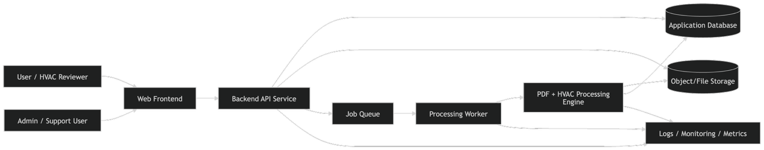

5. Container-Level HLD

Explanation
This view shows the main deployable services.

5.1 Frontend
A browser-based SPA or SSR app, likely React/Next.js, responsible for:
- login
- file upload
- job list
- processing status
- result preview
- output download

5.2 Backend API
A web server, likely FastAPI or Node.js backend, responsible for:
- auth/session integration
- upload orchestration
- job creation
- status retrieval
- result metadata retrieval
- admin endpoints

5.3 Queue
A message broker or task queue such as Redis Queue, Celery, RabbitMQ, or SQS.

5.4 Worker
Consumes queued jobs and performs the heavy processing pipeline.

5.5 Processing Engine
Core analysis modules:
- PDF ingestion
- page rendering
- text extraction
- duct detection
- label association
- measurement
- annotation rendering
- export generation

5.6 Storage
- object storage for source PDFs, rendered images, annotated outputs
- relational DB for users, jobs, page metadata, extracted segments, statuses

Mermaid Diagram

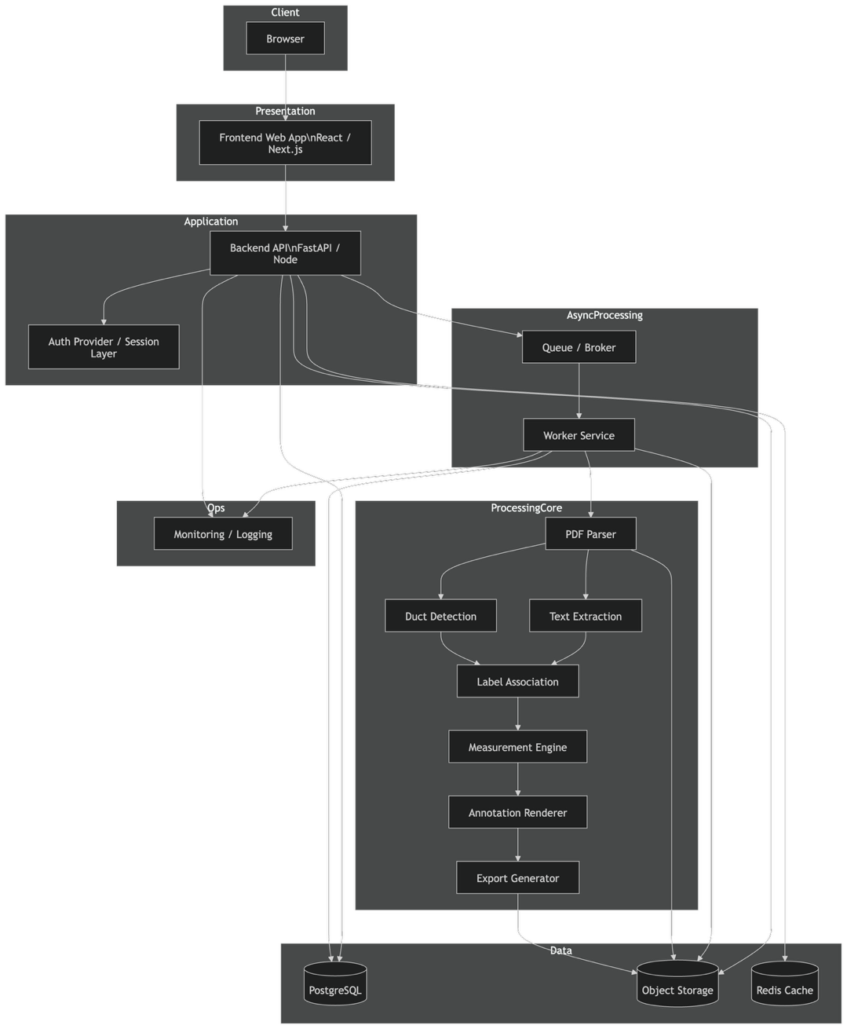

6. Core Processing Pipeline HLD

Explanation
This is the most important application-specific view.
The pipeline is:
- Load PDF
- Validate and extract page metadata
- Render page image
- Detect main plan region and exclude title block/notes
- Extract text and coordinates
- Detect duct geometry
- Build connected duct graph
- Match labels to segments
- Estimate segment lengths
- Render overlays
- Save outputs and metadata
The sample input clearly has large non-plan sections such as notes and title regions, so plan-region isolation is an important early-stage step.

Mermaid Diagram

7. Web Application Flow HLD

Explanation
This diagram shows how the user experience maps to system behavior.
- user uploads PDF
- backend creates job
- queue dispatches work
- worker processes
- outputs are stored
- frontend polls or subscribes for status
- user views results

Mermaid Diagram

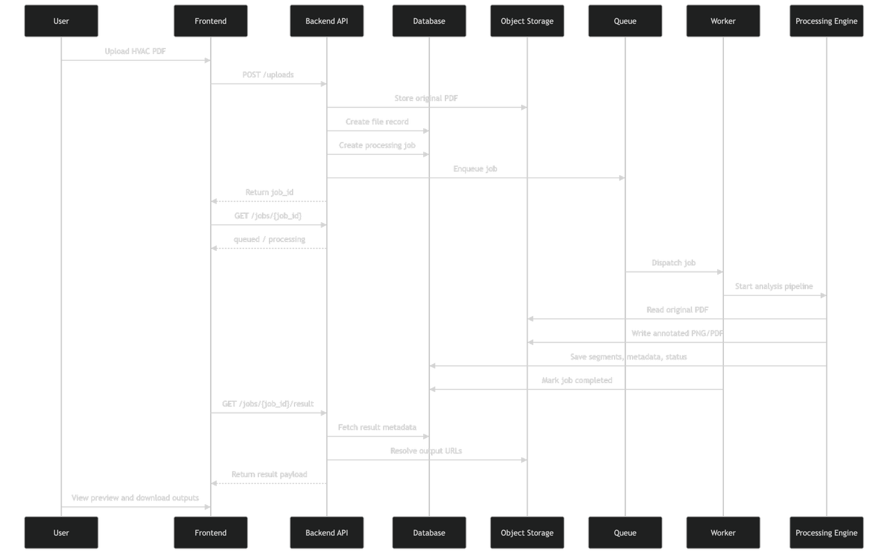

8. Deployment HLD

Explanation
A production deployment should separate stateless web services from compute-heavy worker services.
Suggested deployment blocks:
- CDN / Load Balancer
- Frontend app
- API service
- Worker autoscaling group
- PostgreSQL
- Redis/queue
- object storage
- monitoring stack

Mermaid Diagram

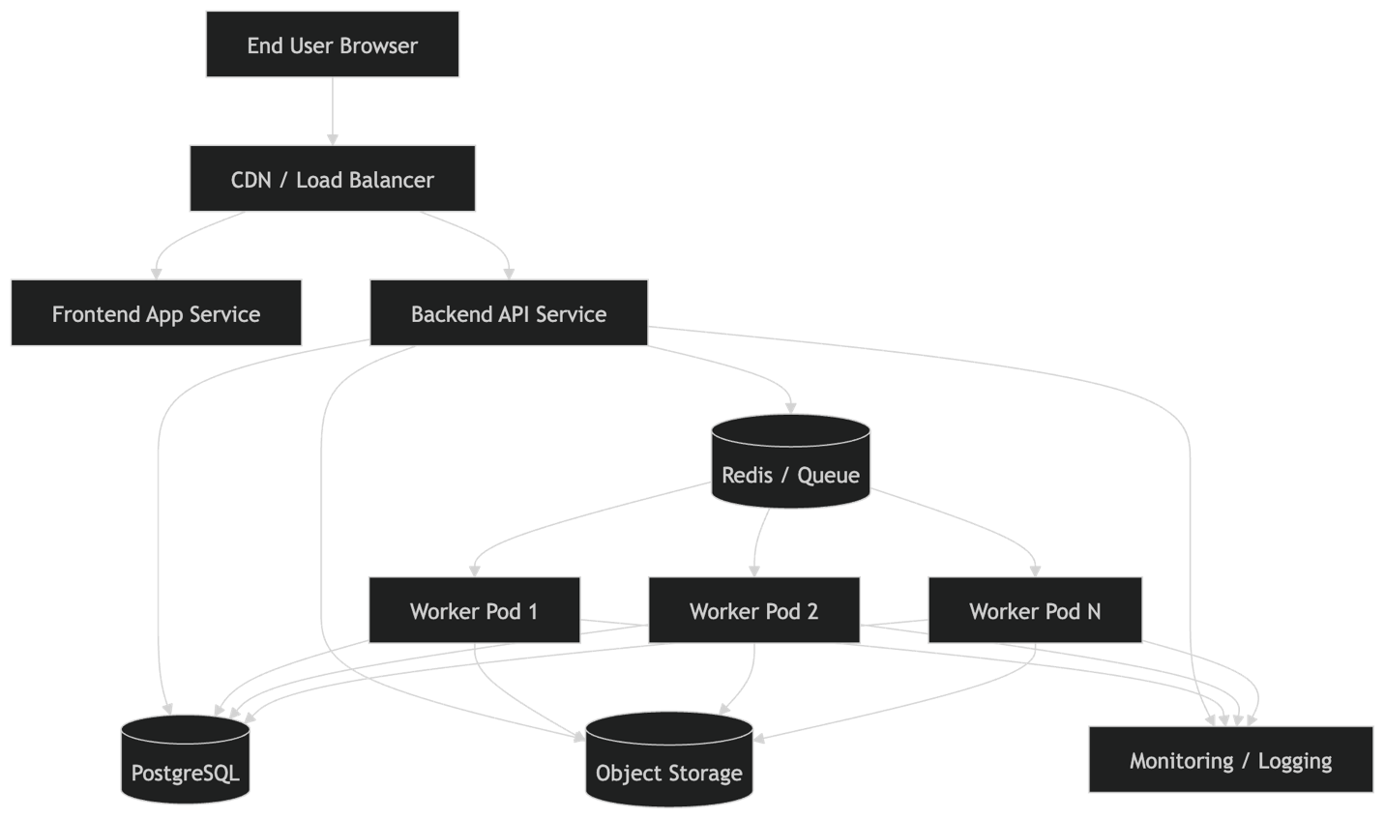

9. Data Flow Diagram (DFD) – Level 0

Explanation
This is the context-level DFD.
External entities:
- User
- Admin
Single main process:
- HVAC Duct Detection Web App

Data stores:
- Job Metadata Store
- File Storage

Mermaid Diagram

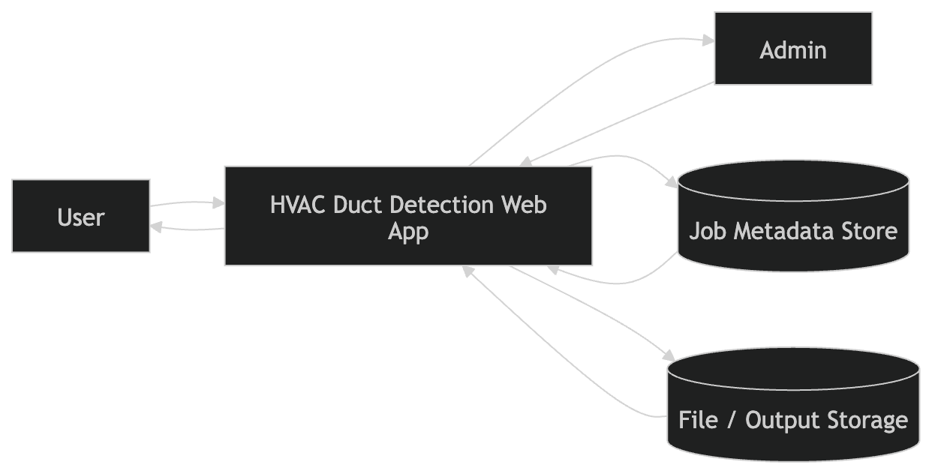

10. Data Flow Diagram (DFD) – Level 1

Explanation
This breaks the app into major internal processes:
- Manage Uploads
- Manage Jobs
- Analyze Drawing
- Generate Outputs
- Serve Results

Mermaid Diagram

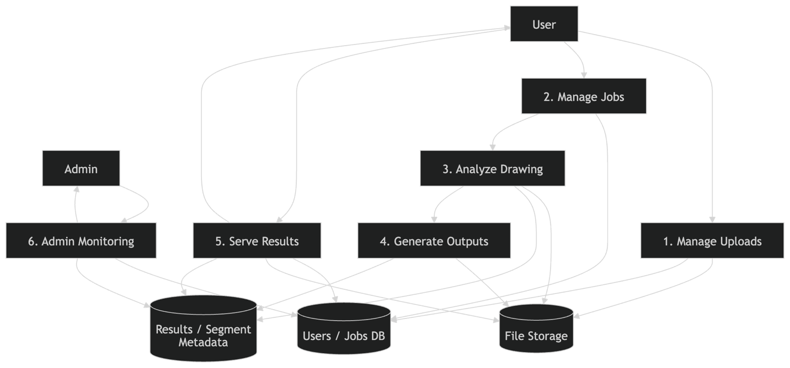

11. Data Flow Diagram (DFD) – Level 2 for Analyze Drawing

Explanation
This is the system’s core engineering process.
Subprocesses:
- validate PDF
- render page
- detect plan region
- extract text
- detect ducts
- build segments
- associate labels
- detect scale
- measure lengths
- annotate/export

Mermaid Diagram

12. Subsystem HLD

12.1 Frontend Subsystem

Responsibilities
- login/session
- upload UI
- job status UI
- result preview
- download actions
- admin/debug view

Mermaid

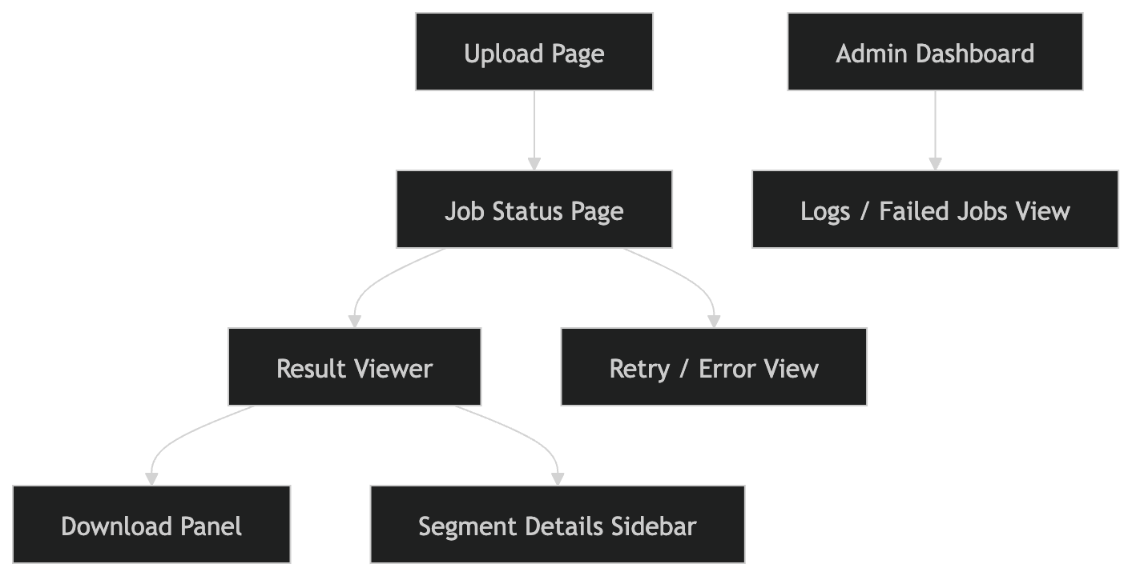

12.2 Backend/API Subsystem

Responsibilities
- auth checks
- uploads
- job lifecycle
- result retrieval
- admin/debug endpoints

Mermaid

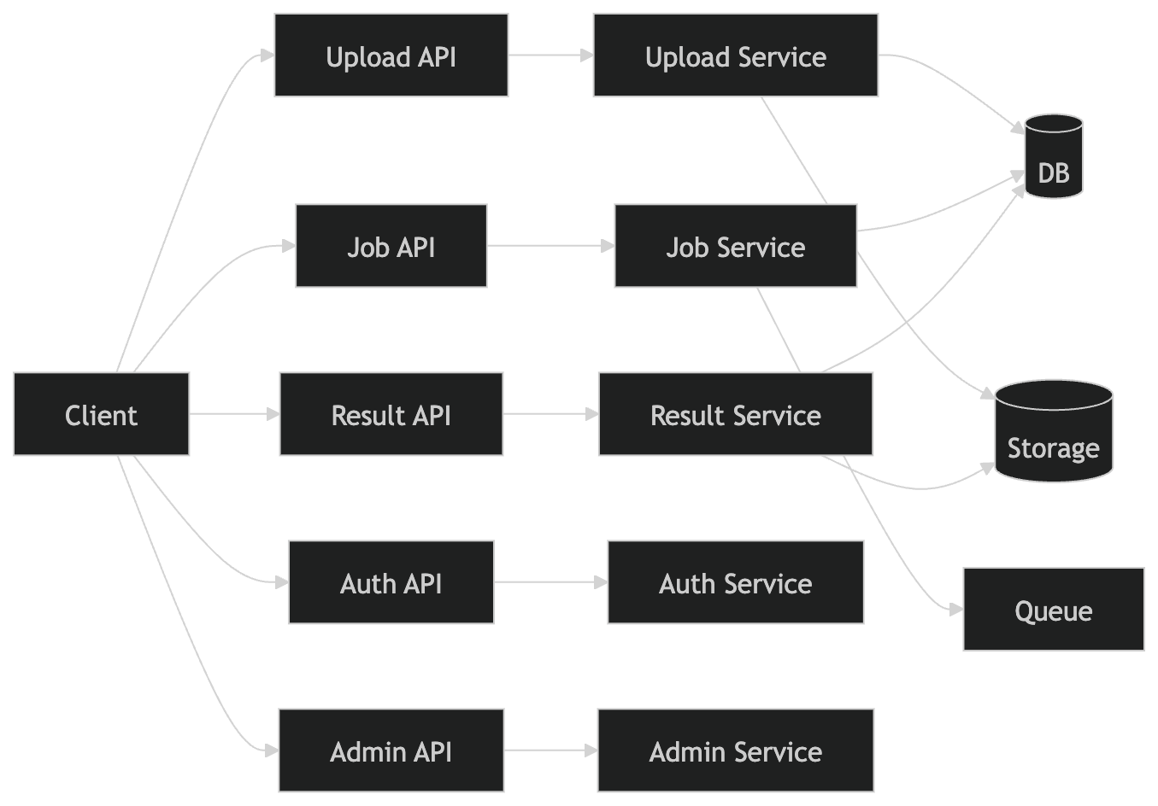

12.3 Processing Engine Subsystem

Responsibilities
- drawing parsing
- text extraction
- duct graph construction
- length estimation
- overlay generation

Mermaid

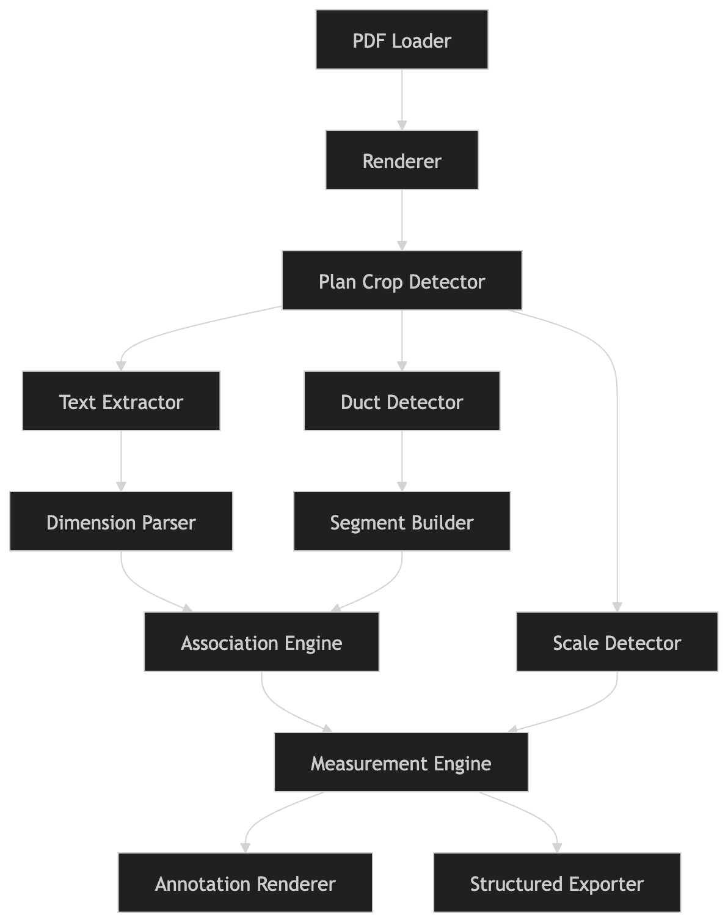

13. Suggested API HLD

Explanation
At high level, the system can expose these endpoints:
- POST /api/files/upload
- POST /api/jobs
- GET /api/jobs/{jobId}
- GET /api/jobs/{jobId}/result
- GET /api/jobs/{jobId}/download/png
- GET /api/jobs/{jobId}/download/pdf
- GET /api/jobs/{jobId}/segments
- GET /api/admin/jobs
- GET /api/admin/jobs/{jobId}/logs

Mermaid

14. Data Storage HLD

Explanation
Two main persistent stores are enough at HLD level:

Relational DB
Stores:
- users
- files
- jobs
- pages
- extracted segments
- result metadata
- logs references

Object Storage
Stores:
- original PDFs
- rendered page images
- debug images
- annotated PNG/PDF
- CSV/JSON exports

Mermaid

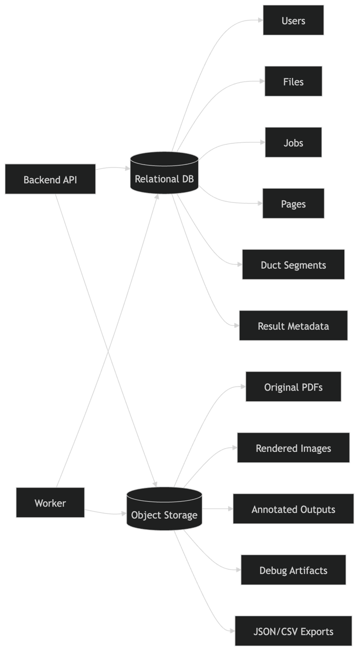

15. Key Architectural Decisions

15.1 Why async job processing
Drawing analysis is CPU-heavy and sometimes memory-heavy. Keeping it outside the request-response cycle avoids timeouts and makes UX better.

15.2 Why object storage
Annotated PNG/PDF files and intermediate images are large binary assets and should not live in relational tables.

15.3 Why modular processing engine
Future improvements may replace only one module, such as:
- duct detector
- OCR/text extractor
- scale calibrator
- annotation renderer
without rewriting the whole app.

15.4 Why separate metadata and file storage
This keeps the system scalable and operationally clean.

16. Recommended Tech Stack at HLD Level
A good web-app stack for this design would be:
- Frontend: React or Next.js
- Backend API: FastAPI or Node.js/NestJS
- Workers: Python workers
- Queue: Redis + Celery / RQ, or RabbitMQ / SQS
- PDF & vision engine: Python
- DB: PostgreSQL
- Object storage: S3-compatible storage
- Monitoring: Prometheus/Grafana or cloud-native monitoring
- Deployment: Docker + Kubernetes or ECS
Python is especially strong here because the core document-analysis pipeline depends on PDF and CV libraries.

17. End-to-End HLD Summary
In one sentence:
This system is a web application with asynchronous document-analysis workers that ingest HVAC mechanical drawing PDFs, isolate the plan area, extract text and duct geometry, associate dimensions and lengths, render annotated overlays, store outputs, and return previewable downloadable results to the user.

